**Advantech AE Technical Share Document**

|  |  |  |  |
| --- | --- | --- | --- |
| **Date** | 2017/08/11 | **SR#** | 1-3008561741 |
| **Category** | ■FAQ □SOP | **Related OS** | N/A |
| **Abstract** | WISE-40XX, How to use scaling function and physical scaling function? | | |
| **Keyword** | WISE, Low scaling value, High scaling value, Physical Min Scaling Value, Physical Max Scaling Value | | |
| **Related Product** | WISE-40XX series | | |

* **Problem Description:**

This documentation explains the detail information about the scaling function of WISE AI module.

When using the AI with different types of sensor, the scaling function can help to convert the raw data into meaningful engineer unit so that HMI (Human Machine Interface) or database can read these data directly to enhance computational time complexity.

* **Brief Solution - Step by Step:**

The scaling function can be found in the configuration of analog input of WISE utility. The scaling setting explanation can be found in “System Configuration” section in WISE-4000 series user manual.

**Scenario**

Here, WISE-4012 is used for demonstration. Scenario is that mapping 0 ~ 50℃ to 0.5 ~ 3VDC. The setting is shown as in figure 1.

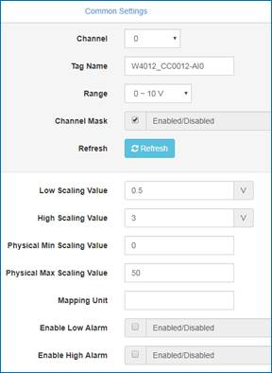 Figure 1. Configuration in WISE utility

**Experiment**

Use power supply to supply 2VDC to WISE-4012 channel 0, which is set as AI mode.

In “Status”, as shown in figure 2, column Value[Eg] shows current voltage received from power supply, column Value[Hex] and Value[Dec] show corresponding raw data in Modbus address, which is shown in figure 3 and 4. User can check these address location from “I/O Modbus Mapping Table” section in user manual.

User can calculate by equation (1) to transform raw data to human readable data format. For example, .



Figure 2. WISE utility I/O Status

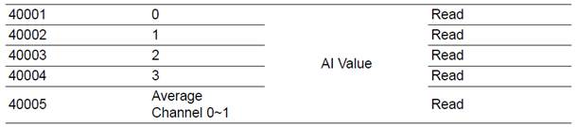

Figure 3. Modbus AI raw data correspond address.

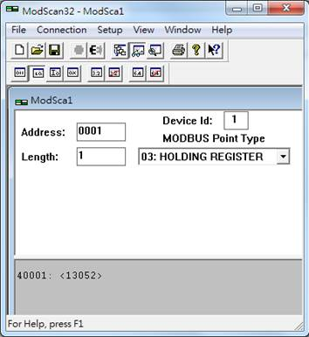

Figure 4. Modbus AI raw data.

(1)

After Low/High scaling value, data is registered in different Modbus address, and will not display on utility. Different WISE module has different corresponding Modbus address, which user can check in user manual as in figure 5. The extracted data is shown in figure 6 and can be transformed into human readable value by formula (1) as well, .

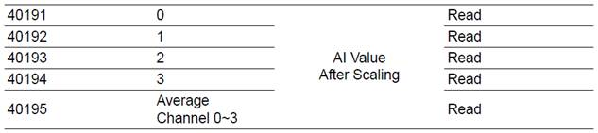

Figure 5. AI value after scaling in corresponding Modbus address.

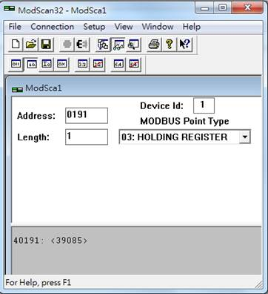

Figure 6. AI value after scaling.

Physical Low/High scaling value, which will not be shown in utility, will mapping 0 ~ 50℃ to Low/High scaling range 0.5 ~ 3V. In this case, if supply WISE-4012 ≦ 0.5V, data 0.000 is registered in Modbus address [40231-40232]; if supply WISE-4012 ≧ 3V, data 50.000 is registered in these addresses.

Note that in these addresses, data format is set as IEEE 754 floating value, which is shown in figure 7 and 8.

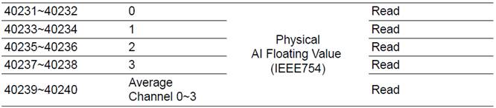

Figure 7. AI value after physical scaling corresponding Modbus address.

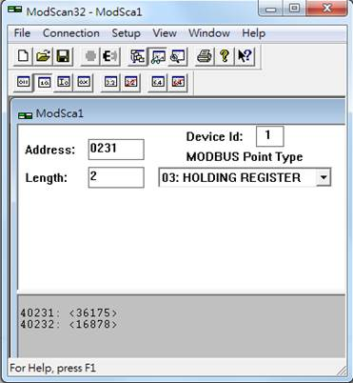     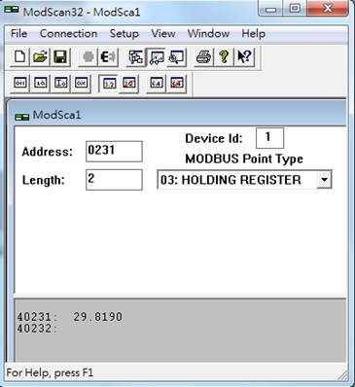

(a) (b)

Figure 8. (a) AI decimal value after scaling. (b) AI **floating value** after scaling.

In figure 8 (b), the result shows that the voltage value 2 supplied by the power supply, refers to temperature 29.8190℃.