Advantech AE Technical Share Document
Date | 2017/10/02 | Release Note | ■External
Category | ■SOP | Related OS | Windows OS
Abstract | How to configure X-ring Pro
Keyword | X-ring , X-ring Pro, Couple-ring, Dual-ring, X-ring-Elite, Legacy Mode
Related Product | EKI-7000, EKI-7700, EKI-7400 series, EKI-9200, EKI-9300 series, EKI-9500 series, EKI-9600 series, EKI-9700 series, EKI-5500/EKI-5600 Protocol switch
- Problem Description:

- What is X-ring Pro technology?
- How to configure the X-ring feature?

- Answer:

[Purpose]
- The X-ring feature provides improvements to Spanning Tree (STP) and Rapid Spanning Tree (RSTP), and is quickly and automatically restored when a network is broken,
- X-ring is designed for the specific environments of industrial applications. It provides high speed redundancy for the network, when anyone of the port failed, the recovery time will be under 20ms.

[Definition]

- It’s a network topology where each node is connected to two other odes.
- To provide Ethernet networks with high-speed redundancy.
- Both X-ring and X-ring Pro are Advantech’s proprietary ring redundancy technology.
- Advantech’s 1st generation ring redundancy technology => X-ring
- Advantech’s 2nd generation ring redundancy technology => X-ring Pro

[Comparison Table for X-ring]

 | X-ring Elite | X-ring Pro | X-ring Pro | X-ring Pro | X-ring
 | NOS5.0 | NOS5.0 | NOS3.0 | NOS2.0 | NOS1.8
Max. Support Unit | 250 | 250 | 250 | 250 | 50
Recovery time | <20ms | <20ms | <20ms | <20ms | < 20ms
Auto Ring Master Selection | Not Required | Not Required | Not Required | Not Required | Required
Couple-Ring Support | NO | Yes | Yes | Yes | YES
Dual-Ring Support | NO | Yes | Yes | Yes | No
Coupling-Ring & Dual-Homing Limitation | No | No | No | No | Yes (*)
Coupling Ring Control Port | Not Required | Not Required | Not Required | Not Required | Required
Chipset Solution | Realtek | Realtek | Broadcom | Marvell | Marvell

[Note] X-ring with NOS1.8 is phase out

[Support model list]

 | X-ring Elite | X-ring Pro | X-ring Pro | X-ring Pro
 | NOS5.0 | NOS5.0 | NOS3.0 | NOS2.0
Max. Support Unit | EKI-7428-4CI  EKI-7428-4CPI  EKI-7706E-2F/ EKI-7706G-2F  EKI-7708E-4F(I)/ EKI-7708E-4FP(I)  EKI-7708G-4F(I)/ EKI-7708G-4FP(I)  EKI-7710E-2C(I)/ EKI-7710E-2CP(I)  EKI-7710G-2C(I)/ EKI-7710G-2CP(I)  EKI-7712E-4F(I)/ EKI-7712E-4FP(I)  EKI-7712G-4F(I)/ EKI-7712G-4FP(I)  EKI-7716E-4F(I)/ EKI-7716G-4F(I)  EKI-7720E-4F(I)/ EKI-7720G-4F(I)  EKI-9612  EKI-9628 |  | EKI-9228  EKI-9312  EKI-9312P  EKI-9316  EKI-9316P  EKI-9512  EKI-9512P  EKI-9512D  EKI-9512D-P  EKI-9516  EKI-9516P  EKI-9516D  EKI-9516D-P  EKI-9728 | EKI-7554M/S  EKI-7559M/S  EKI-7654C  EKI-7659C  EKI-7656C  EKI-7657C  EKI-7659CPI  EKI-2748FI  EKI-2748CI  EKI-7758F  EKI-6558TI  EKI-6559TMI
EKI-5528-PNMA
EKI-5528(I)-PN
EKI-5526(I)-PN
EKI-5528(I)-EI
EKI-5526(I)-EI
EKI-5528(I)-MB
EKI-5526(I)-MB
EKI-5629C(I)-PN
EKI-5626C(I)-PN
EKI-5629C(I)-EI
EKI-5626C(I)-EI
EKI-5629C(I)-MB
EKI-5626C(I)-MB

- Single X-ring Configuration

- Topology Diagram
Below diagram is the example for the single ring application.
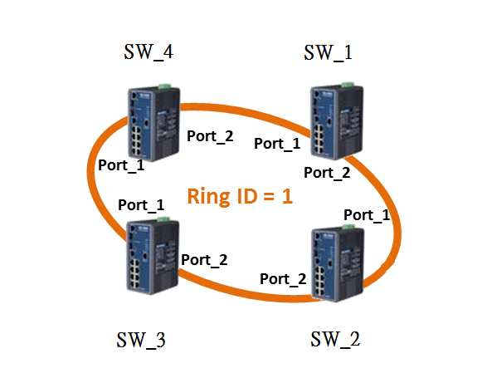

- Web screen shot

Below screen shot show you the X-ring Pro configuration on the web:
SW_1~SW_4
(Each Ring must assign unique ring id, the maximum ring id is 255)
- Port 1 and Port 2 of SW_1 to SW_4 belong to same partition with Ring ID = 1

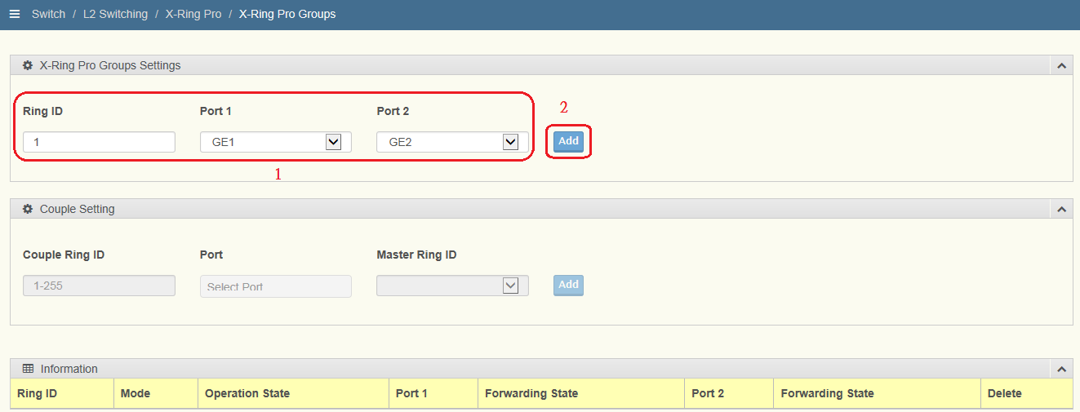
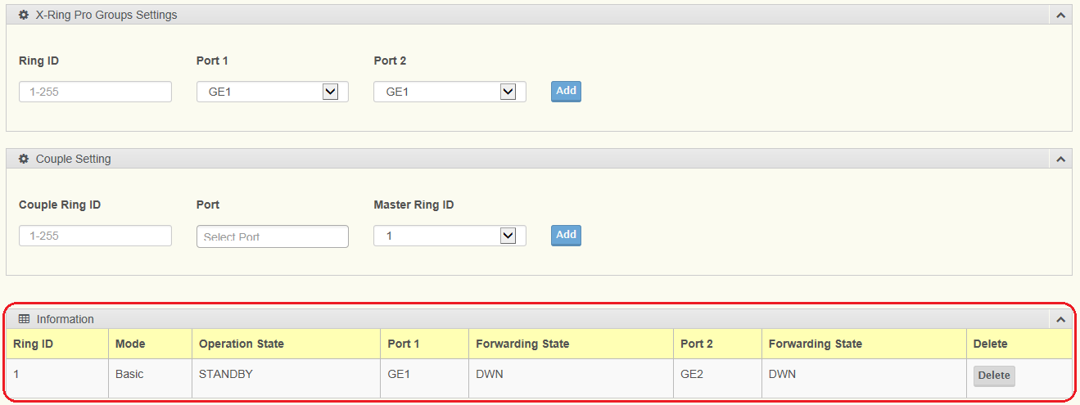

- Couple Ring Configuration

- Topology Diagram
Below diagram is the example for the couple ring application.

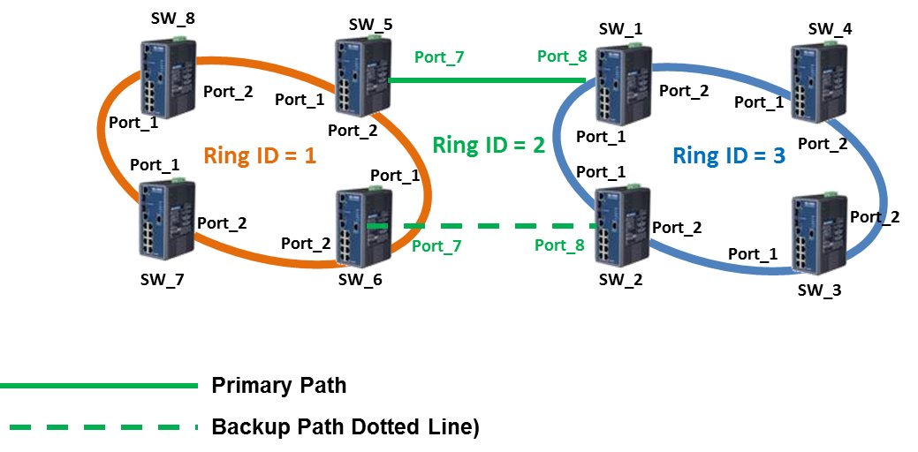

- Web screen shot

Below screen shot show you the X-ring Pro configuration on the web:
SW_7, SW_8

- Port 1 and Port 2 of SW_7 and SW_8 belong to same partition with Ring ID = 1

SW_5, SW_6

- Port 1 and Port 2 of SW_5 and SW_6 are also belong to same partition with Ring ID = 1
- Port 7 belong to different partition with Ring ID = 2 and associating it to Partition 1 by selecting “Ring 01” in the Master Ring Port

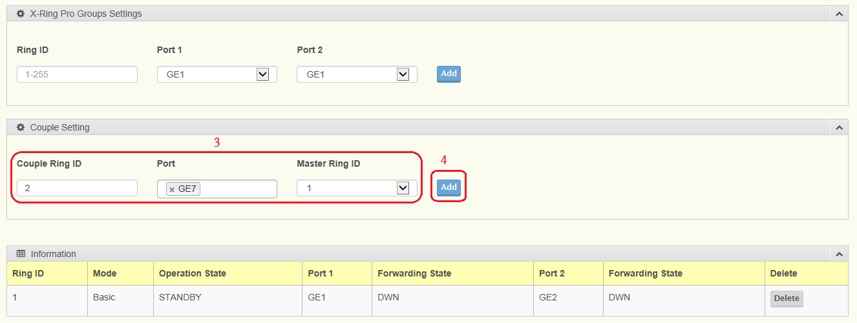
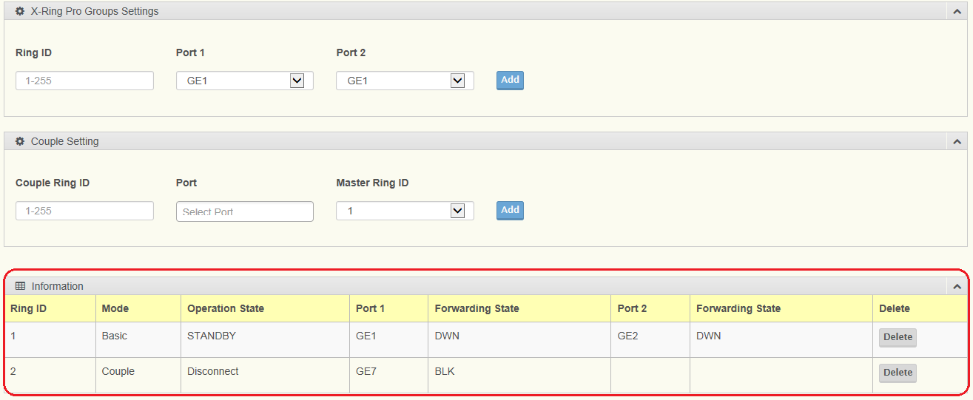

SW_1, SW_2

- Port 1 and Port 2 of SW_1 and SW_2 are also belong to same partition with Ring ID = 3
- Port 8 belong to different partition with Ring ID = 2 and associating it to Partition 3 by selecting “Ring 03” in the Master Ring Port

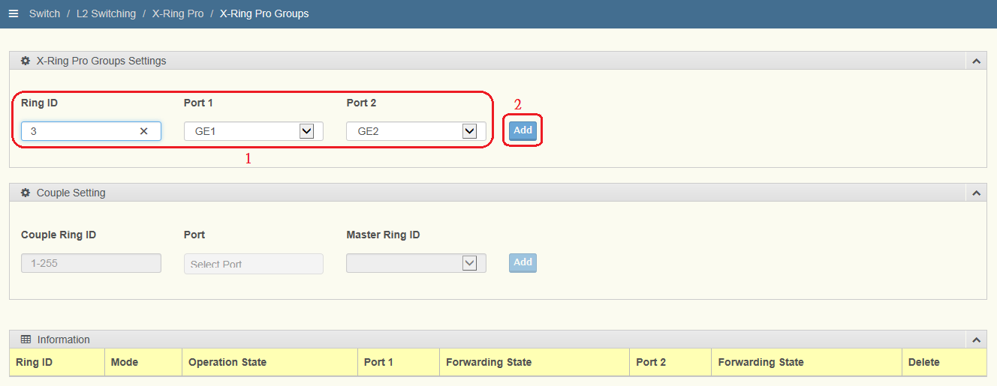

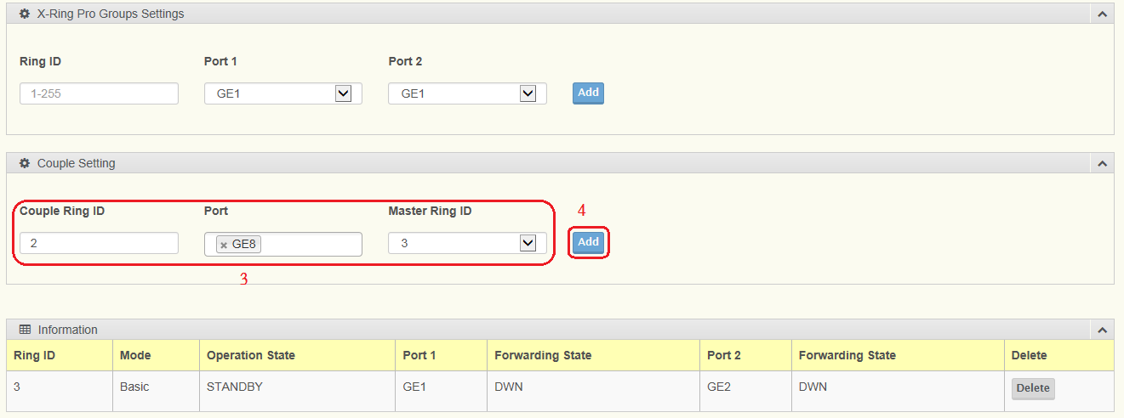

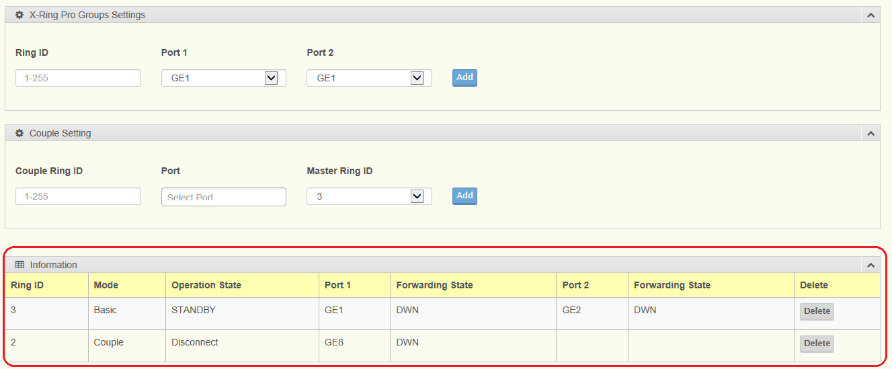

SW_3, SW_4

- Port 1 and Port 2 of SW_3 and SW_4 belong to same partition with Ring ID = 3

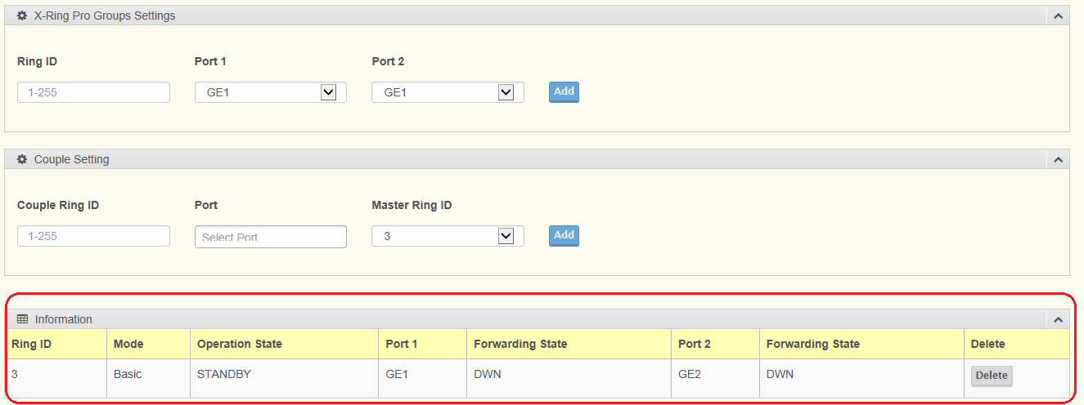

3. Dual Ring Configuration

- Topology Diagram
Below diagram is the example for the Dual Ring application
Dual-Ring:
- Two adjacent rings share one switch.
- Ideal for application that have inherent cabling difficulties.

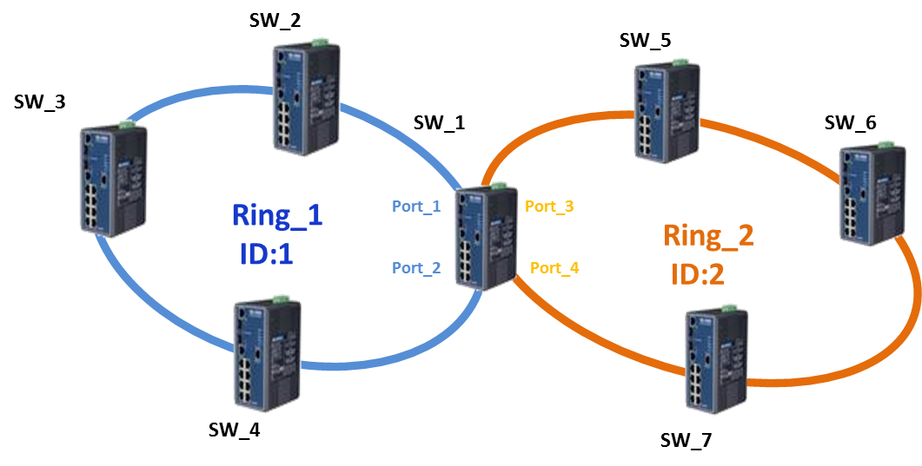

- Web screen shot

SW_1
SW_1 Configuration:
- Port 1 and Port 2 => Ring ID 1
- Port 3 and Port 4 => Ring ID 2

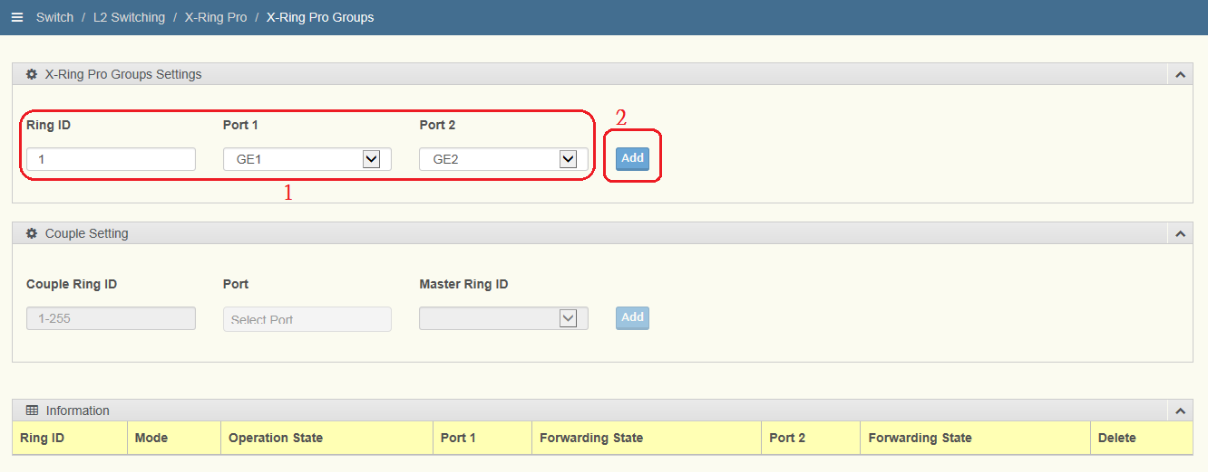
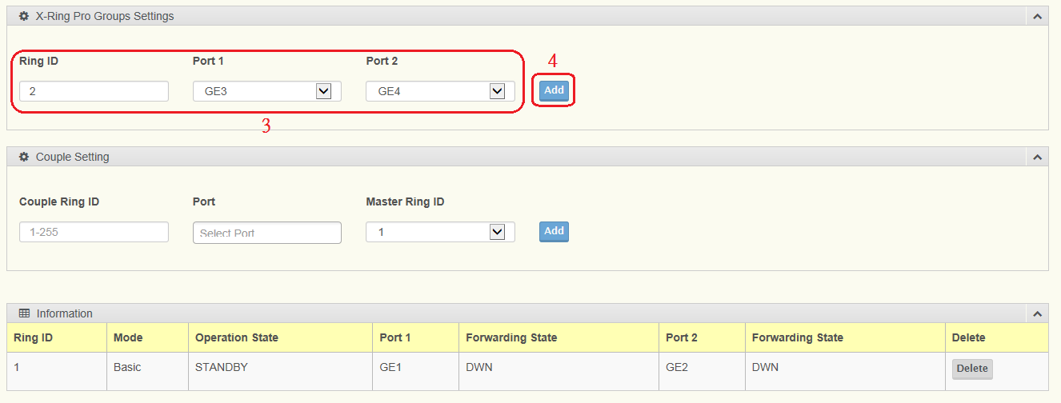

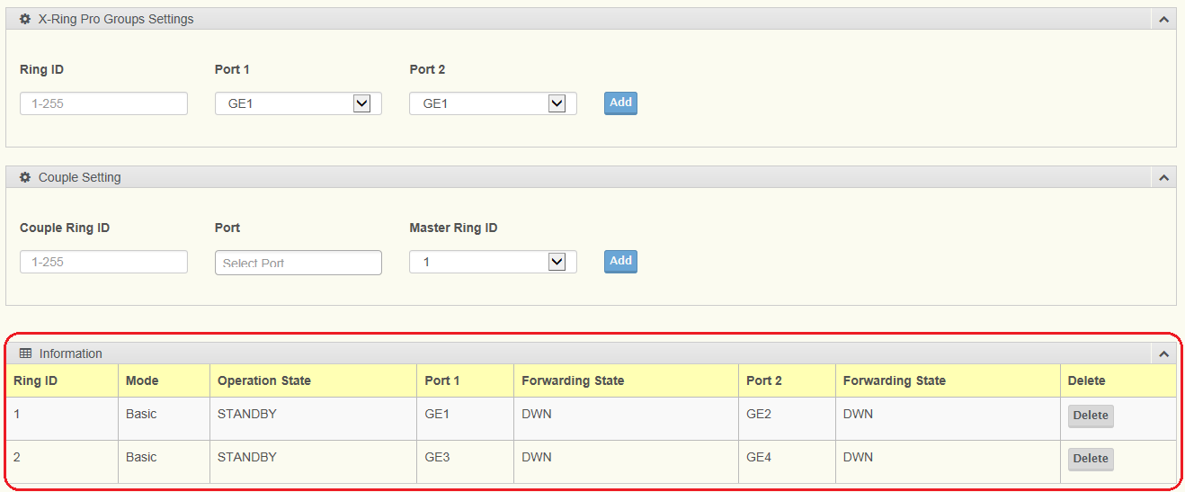

SW_2, SW_3 and SW_4

SW_2, SW_3 and SW_4 Configuration:
- Port 1 and Port 2 => Ring ID 1

SW_5, SW_6 and SW_7

SW_5, SW_6 and SW_7 Configuration:
- Port 1 and Port 2 => Ring ID 2

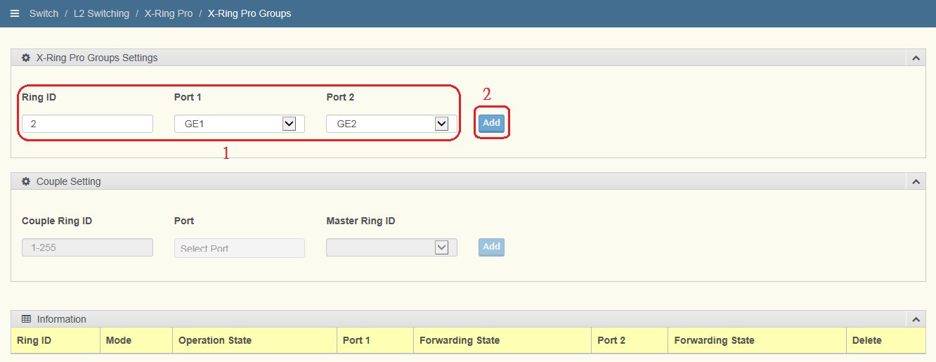

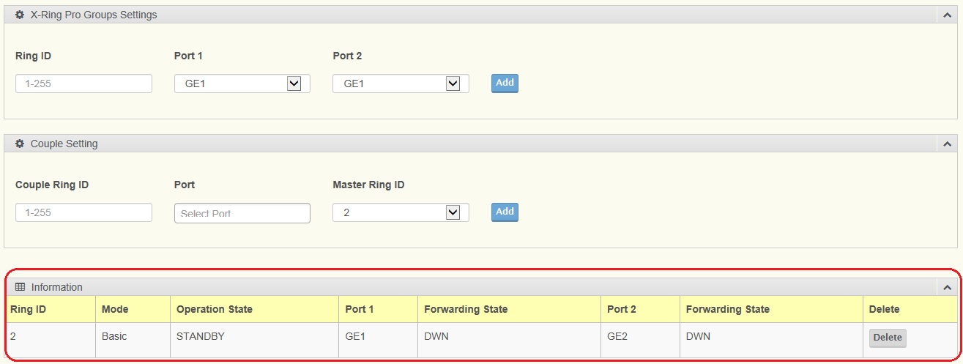

4. X-ring Elite Configuration

- Topology Diagram
Below diagram is the example for the X-ring Elite application for a single ring. You may extend the topology to dual ring, multi ring.
[Note: X-ring Elite is support Dual Ring, Multi Ring. But X-ring Elite do not support couple ring]

- Web screen shot

Below screen shot show you the X-ring Elite configuration on the web:
SW_1~SW_4
(Each Ring must assign unique ring id, the maximum ring id is 255)
- Port 1 and Port 2 of SW_1 to SW_4 belong to same partition with Ring ID = 1

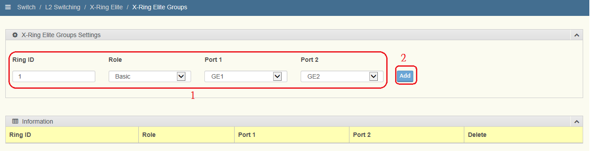

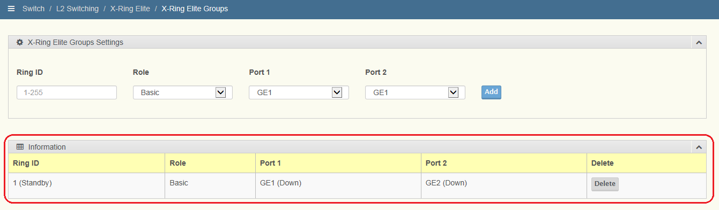

APPENDIX

5. Compatible with previous
X-ring Configuration
(X-ring Pro Legacy Mode)
EKI-7000

- Topology Diagram
- The New X-ring Pro Based FW Switch is backwards compatible with previous X-ring in the existing legacy X-ring network.
- Co-existence Requirement Between X-ring Pro and X-ring:
  - “Legacy Ring” must be manually enabled under X-ring Elite Based FW Switch.
  - Making sure at least one switch from the existing legacy X-ring group configured as “Ring Master”

Below diagram is the example to add a new EKI-7700 and EKI-7400 switch into X-ring (EKI-7000) as a ring member application.

[Purpose] Adding new EKI-7700 and EKI-7400 switches into original EKI-7000 X-ring

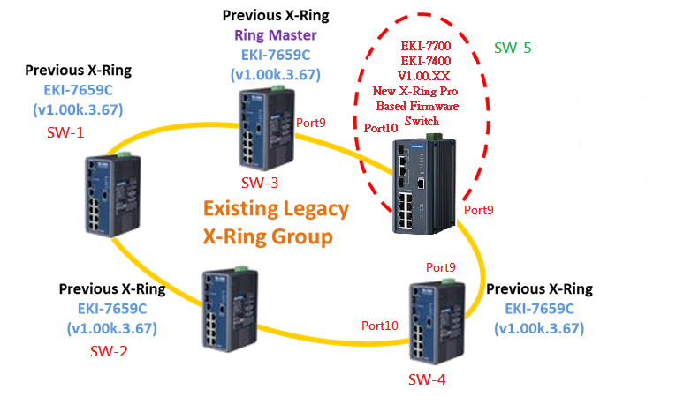

- [Process]
Step1: Configure new switch SW-5 as legacy mode and setting the ring port is port9, and port 10.
Step2: Disconnect the link between SW-3 and SW-4
Step3: Link SW-3 port9 to SW-5 port10 and SW-4 port9 to SW-5 port9

- Web screen shot
Below screen shot show you the X-ring Elite configuration as Legacy Mode on the web, after the setting, you can connect SW5 into the X-ring environment.
SW-5

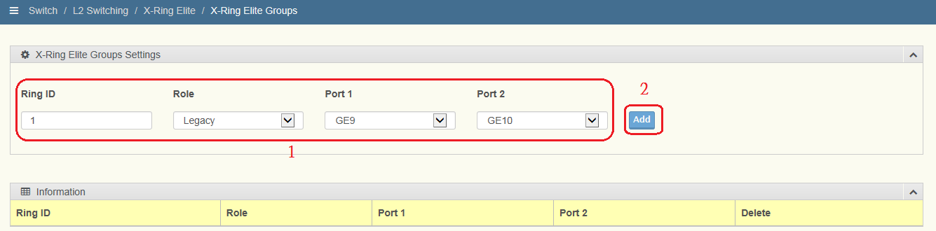

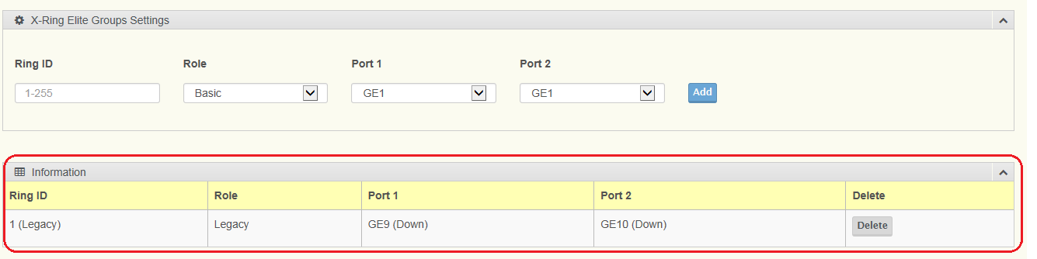

- Contact Window and File Link:
If you have any questions, please contact with local technical support

