USB-Ethernet Dongle Hot Plugging Settings
Data Create | 2014/10/22 | Release Note | □ Internal ■ External
Category | FAQ | Product Group | SAG
Function | USB-Eth | Related OS | Android 4
Related Product | TREK-723
[Abstract]
To realize the USB-Ethernet dongle’s hot plugging function on TREK-723 with Android, some modifications need to be done every time the device boots.

[Solution]
Turn on the device with the dongle unplugged.
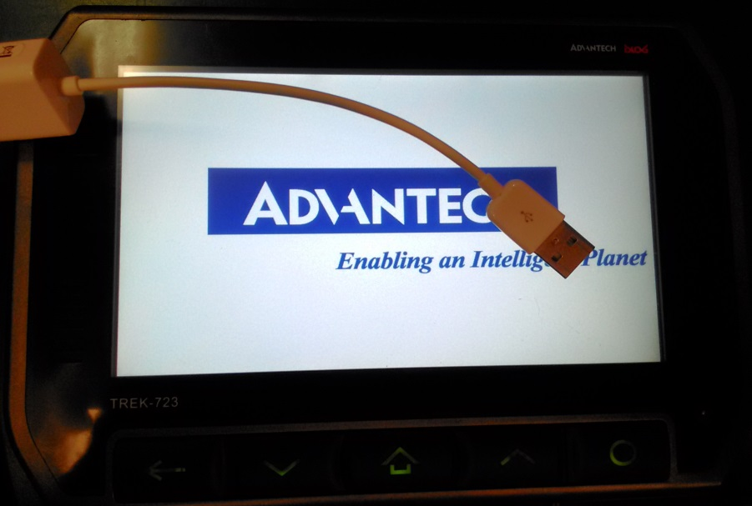
Plug in the dongle. TREK-723 is unable to connect to the internet now.
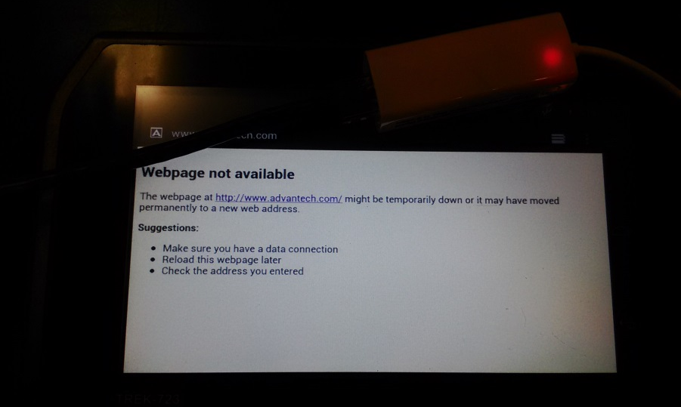
This is the most important step. Go to Settings Ethernet configuration, turn off the Ethernet and turn it on again. Android will automatically fetch a new IP address in this step.
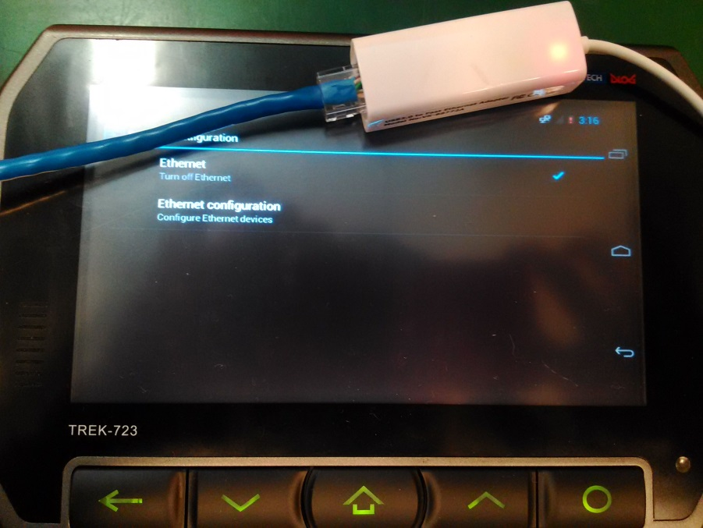
Click Ethernet configuration. It seems unable to specify the Ethernet device. However, it doesn’t interfere with the Ethernet function.
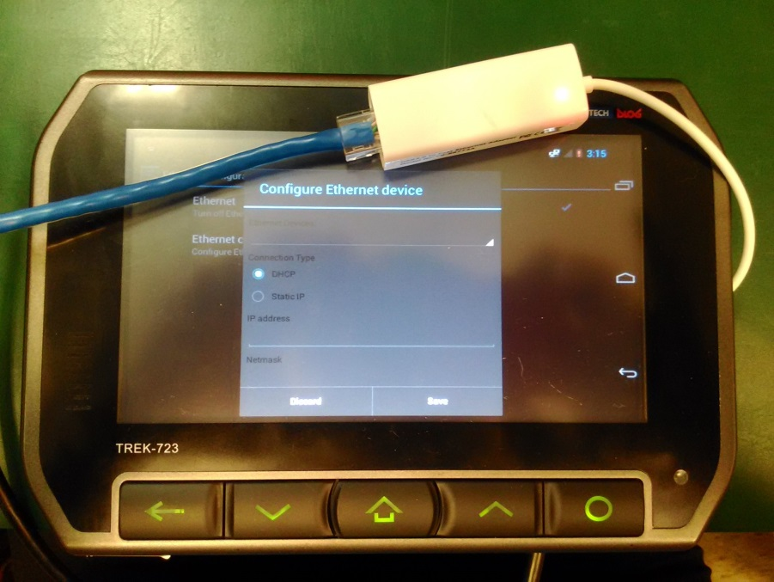

Go to the web browser again. The internet connection is resumed and works fine.
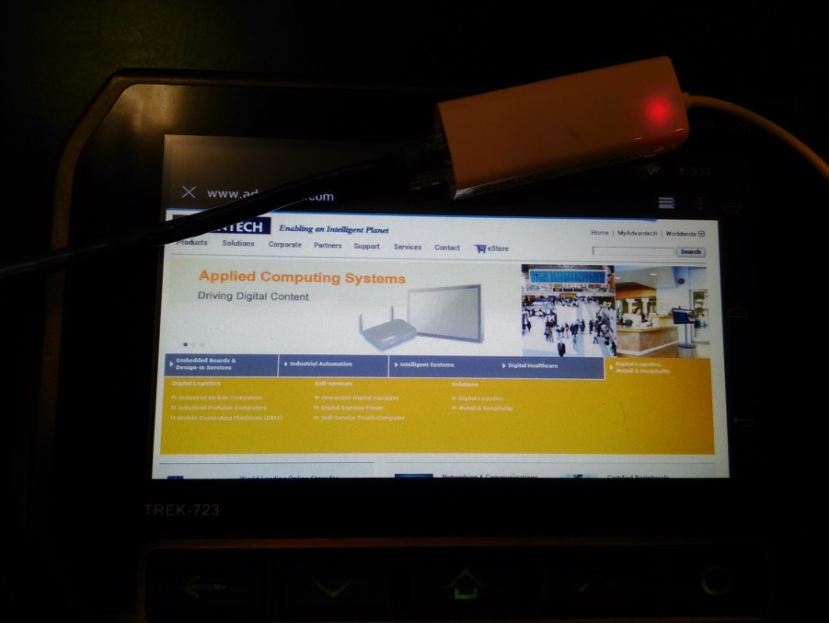
This is how to realize hot plugging with the USB-Ethernet dongle on Android.

