PWS-870 Embedded Controller FW flashing
Data Create | 2014/11/06 | Release Note | □ Internal ■ External
Category | FAQ | Product Group | SAG
Function | EC FW update | Related OS | -
Related Product | PWS-870
[Abstract]
PWS-870 may have an issue that there are a few seconds of non-reactive time when device wake up from sleep or hibernation. Updating the EC FW can fix this problem

[Preparation]
- DOS bootable media
- The .bin file to flash, name it EC.bin

[Solution]
Unzip the attached file (EC_FW_flashing.zip) above.
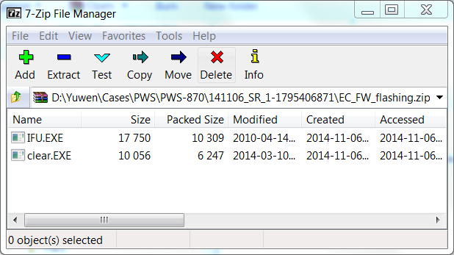

Copy the file clear.EXE, IFU.EXE and EC.bin to the DOS bootable media, and then boot your device under DOS.
C:\>dir

Volume in drive C is ABC
Volume Serial Number id XXXX-XXXX
Directory of C:\

CLEAR EXE 10,056 03-10-14 4:47p
IFU EXE 17,750 04-14-10 3:09p
EC BIN 98,304 11-06-14 3:44p

Execute clear, and click Enter.
C:\>clear
eeprom table erase successful.

Execute ifu EC.bin, and click Enter.
C:\>ifu EC.bin

The device will update the EC FW and turn off. Now unplug the power input. Plug the power input and boot. The EC FW is successfully updated.

