**BIOS Flashing Failure Due to Write-Protection**

|  |  |  |  |
| --- | --- | --- | --- |
| **Data Create** | 2014/11/10 | **Release Note** | □ Internal ■ External |
| **Category** | FAQ | **Product Group** | SAG |
| **Function** | BIOS flashing | **Related OS** | - |
| **Related Product** | AMiS-50, all | | |

**[Question]**

Why is there an error message “Error: BIOS is write-protected” when using AFUDOS to flash BIOS firmware?

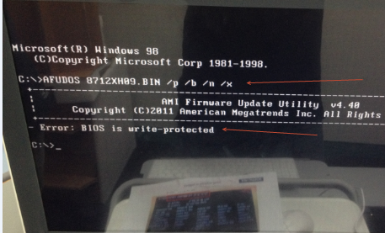

**[Solution]**

There are 2 kinds of AMI BIOS, Core 8 and Aptio (also called EFI).

|  |  |
| --- | --- |
| Core 8 | Aptio(EFI) |
| AMI Core8.JPG | Setup Aptio.JPG |

They don’t share the same utility to flash the firmware, but their utilities normally have the same file name **AFUDOS.EXE**. Here in example, we rename them into **AFUDOS_C.EXE** and **AFUDOS_E.EXE** for core 8 and Aptio respectively.

When the utility **AFUDOS_C** tried to flash an **Aptio BIOS**, the error message displayed

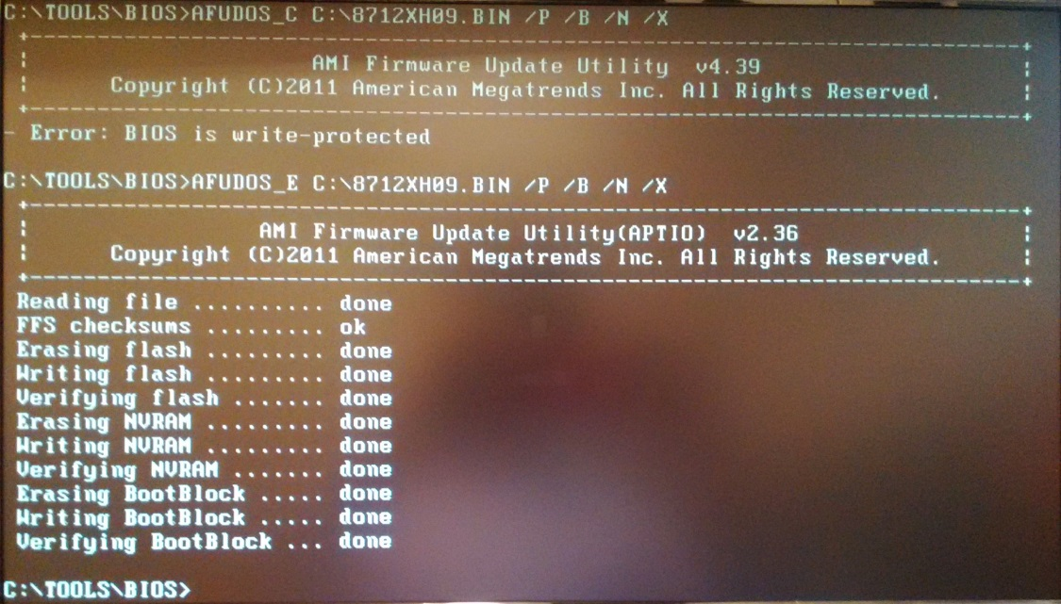

To fix this error, simply use the correct version (**AFUDOS_E**) of utility to redo the flashing.