Advantech AE Frequently Asked Questions
Data Create | 14/11/19 | Release Note | ■ Internal ■ External
Category | FAQ | Product Group | SAG
Function | Battery Icon | Related OS | Win7
Related Product | AMiS
[Abstract]
Why computer cannot detect battery.
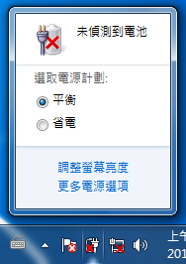
[Solution]
Right click on tool icon tool bar, and cancel the battery icon.
This issue course by the MB is designed for panel PC, so there is a hardware port to detect embeds battery. But IPS does not send the signal on the same way, it by comport.
So we build a new FW to remove the battery detect function on MB to fix this issue.

FW: 8712XH09.BIN
料號: 1420035196

