Advantech AE Technical Share Document
Date | 2017/11/23 | SR#
Category | ■FAQ □ SOP | Related OS | N/A
Abstract | What is the meaning of P-Fail and how does it work on the machines?
Keyword | P-Fail, Relay, P-Fail LED, Alarm LED, Power Failure, Port Link-down, Fiber Link-down, Dual Power, Single Power
Related Product | EKI-7700 series, EKI-7428, EKI-7659, EKI-9612, EKI-9628, EKI-9728

- Problem Description:
Q1: What is the meaning of P-Fail, and how does it work on the machines?
Q2: How to set the corresponding P-Fail actions among different models?
- Answer:
For Q1:
P-Fail is a relay that we can use it to quickly diagnose the status of switches. P-Fail can stand for Power-Failure or Port-Failure which means normally it can be related to the power issues or connection problems. When the power or connection on switch fails, the relay circuit will be triggered as on/off which can then trigger gadgets attached onto it, such as LED (Alarm/P-Fail) indicators, to inform failure information.
P-Fail relay has two action modes. Users can distinguish it by expressions on switches, and please refer to the Figure 1 and Figure 2.
- As the expression of figure 1 describes, the arrow directs inward of the P-Fail which means the relay circuit is CLOSED when P-Fail is triggered.
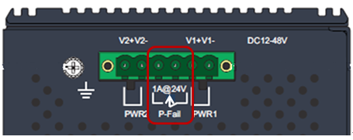
Figure 1. P-Fail graphic expression (Close)
- As the expression of Figure 2 describes, the arrow directs outward of the P-Fail which means the relay circuit is OPENED when P-Fail is triggered.
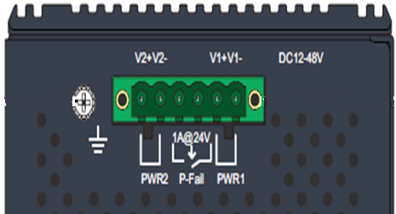
Figure 2. P-Fail graphic expression (Open)
Taking dual power as an example, switches that support dual power will have the P-Fail triggered while one of the power supply failed (please refer to the Figure 3). In this mode, LED indicators on these switches will then be activated because its default action is set to be turned on when the circuit is opened.
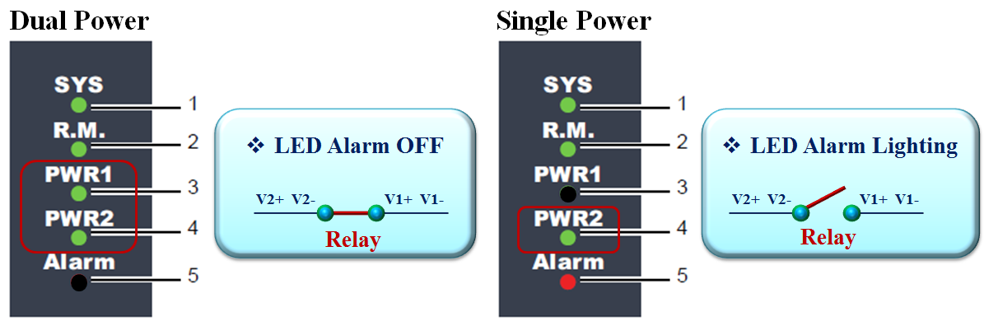
Figure 3. Alarm LED for dual power

For Q2:
The LED indicators are called Alarm or P-Fail LED on switches and can be configured to activate when Power Failure or Fiber Link-down or Port Link-down based on different models. Figure 4 shows the overall P-Fail comparison. Besides, Figure 5 (a) and (b) shows examples of how to set the indicators on websites

 | P-Fail Trigger Mode | Functions | LED
EKI-7700 Series EKI-9612 | Open | Power Failure  Fiber Link-down  Port Link-down | Alarm
EKI-7659 | Open | Power Failure  Fiber Link-down  Port Link-down | P-Fail
EKI-7428 | Close & Open | Power Failure  Fiber Link-down  Port Link-down | P-Fail
EKI-9628 | Close & Open | Power Failure  Fiber Link-down | P-Fail
Figure 4. Overall P-Fail Comparison
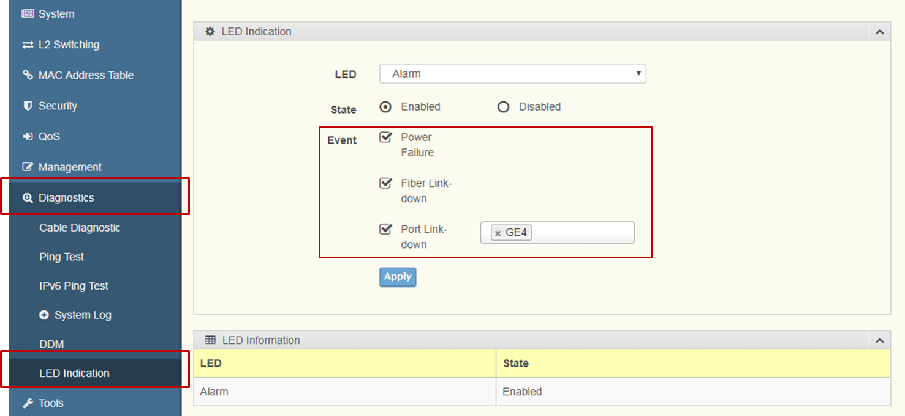
Figure 5(a). EKI-7710 Alarm LED settings
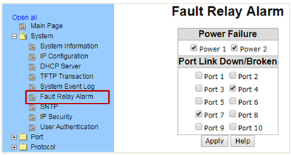
Figure 5(b). EKI-7659 P-Fail LED settings
- EKI-9728G:
There is a special model EKI-9728G that adopts more complicated event-based alarm LED settings. The LEDs have three modes: On, Blinking, and No action and it will be activated depend on the severity level of different events ( please refer to Figure 6 ). We can set these event severity levels and which events should be triggered by using web GUI. Noted that the Blinking LED status can only be seen in the console, it won’t be shown on the website.
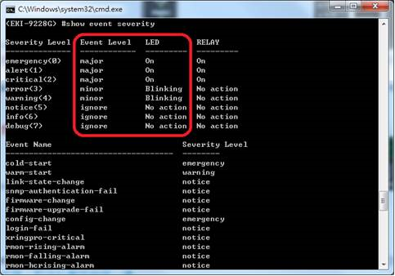
Figure 6. EKI-9728 Event-based Alarm LED in console

