Advantech AE Technical Sharing Document
Date | 2021/ 6 / 1 | Release Note | □ Internal ■ External
Category | ■ FAQ □ SOP | Related OS | Windows、Linux
Abstract | Some PCIe cards cannot be detected by CN14/CN31
Keyword | Network card/WIFI/Bluetooth/BIOS/mPCIe/USB
Related Product | UNO-1483

- Problem Description:
- CN14 and CN31 cannot detect wireless network cards, only CN6 can be used.
- This FAQ can be applied to WIFI (mPCIe) and Bluetooth (USB) network cards
- We take EWM-W188M2(WIFI+Bluetooth) as example
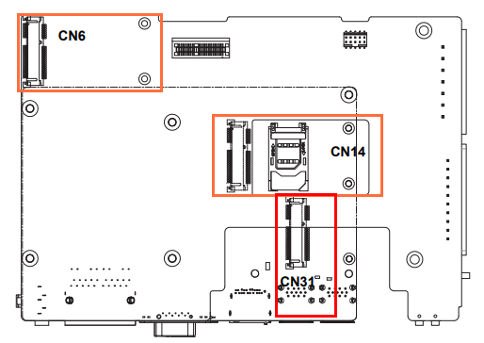

- Brief Analysis and Solution :

- CN14 : It is set to mSATA by default, and mPCIe cards cannot be used.
*For special needs, please contact ACL PAE team.
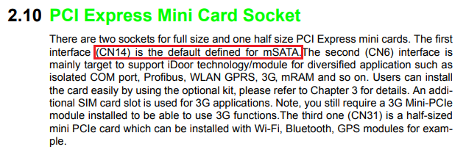
- CN31 : It needs been adjusted BIOS settings :
  - Chipset→PCH-IO Configuration→PCI Express Configuration→PCI Express Root Port X-→ASPM[Disable]
  - Chipset→PCH-IO Configuration→PCI Express Configuration→PCI Express Root Port X-→Detect Non-Compliance Device[Enable]
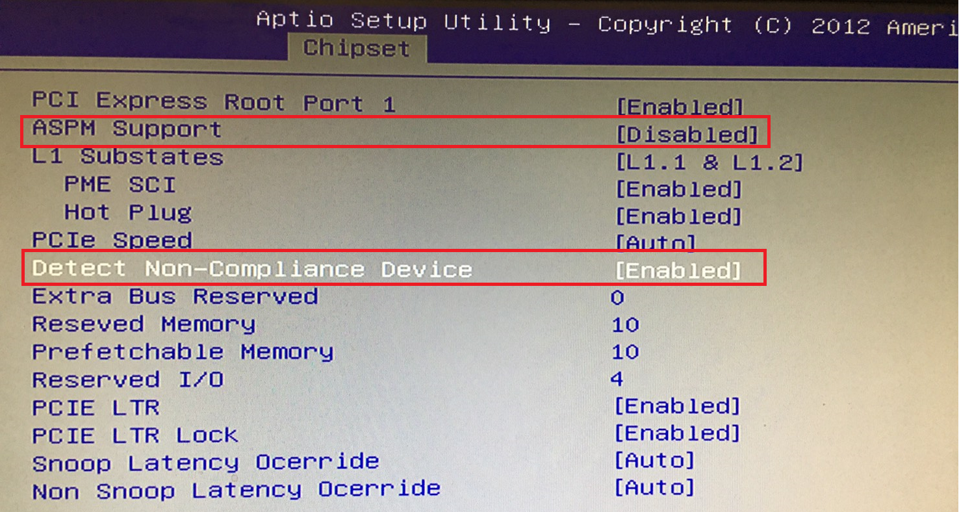
*Note: CN31 does not provide USB signal and does not support Bluetooth function.

- PCI Express Root Port X default sequence :
  - Port 1 : CN31
  - Port 3 : CN14
*Please select the PCI Express Root Port X of the above options in this order.
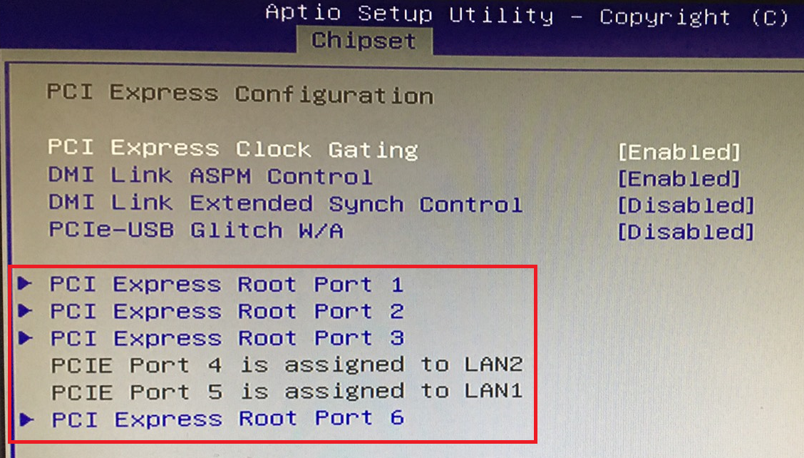
- Contact Window:
If you need further information from headquarter, please contact ACL PAE team.

