Advantech AE Frequently Asked Questions
Data Create | 2014/09/09 | Release Note | ■Internal □ External
Category | FAQ | Product Group | SAG
Function | System | Related OS | Linux(trek520_sd_20141002)
Related Product | TREK-520

[Abstract]
TREK-520 Linux Unlock Keyring while using Wifi

[Solution]

- In the panel, right click the internet (wireless or wired) icon.

- Select "edit connections."

- Select the type of connection (wired or wirelesss)

- If wireless, select the name of your network. if wired, select eth0.

- Select "available to all users" box at the bottom of the box.

- Click "save."

- Reboot

8. The annoying keyring issue should be gone.

- Wireless Network Setting in First time

Input AP’s Password
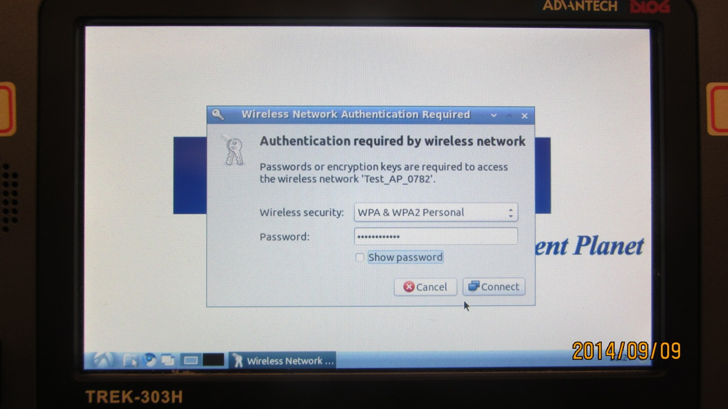

Setting Keyring Password and confirm again
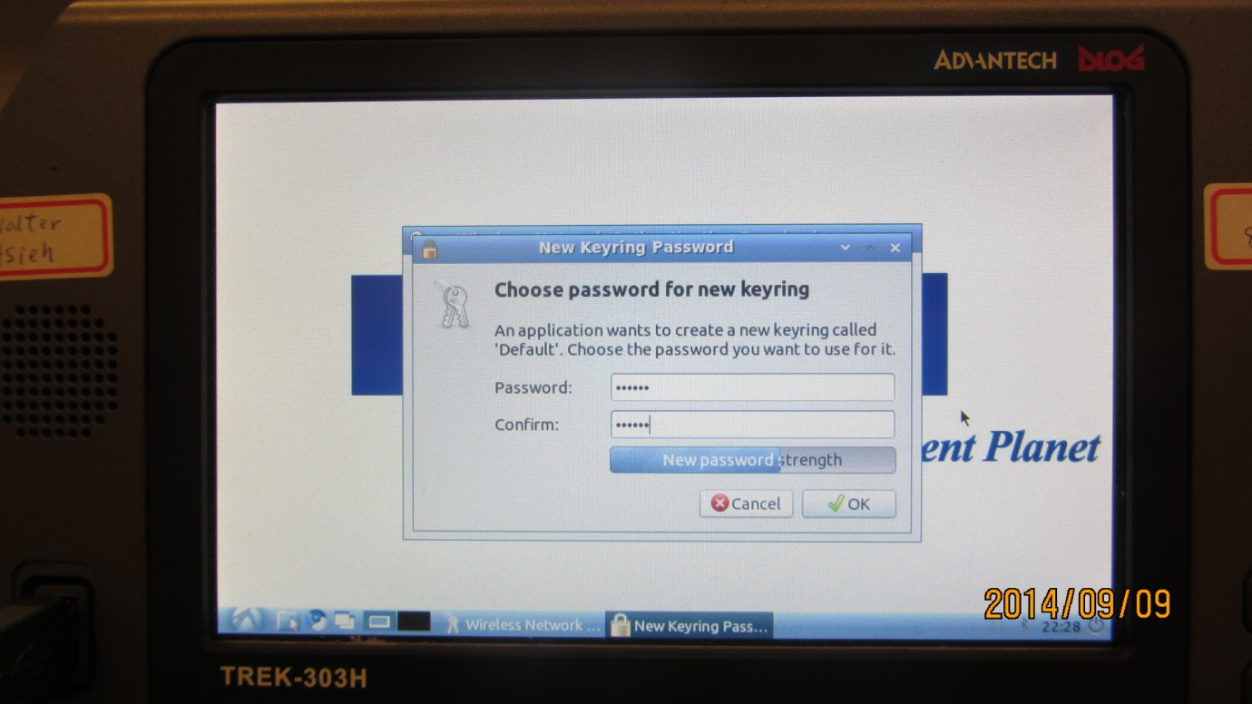

- Reboot system

Every time reboot to system, you will see “Enter Password for keyring”
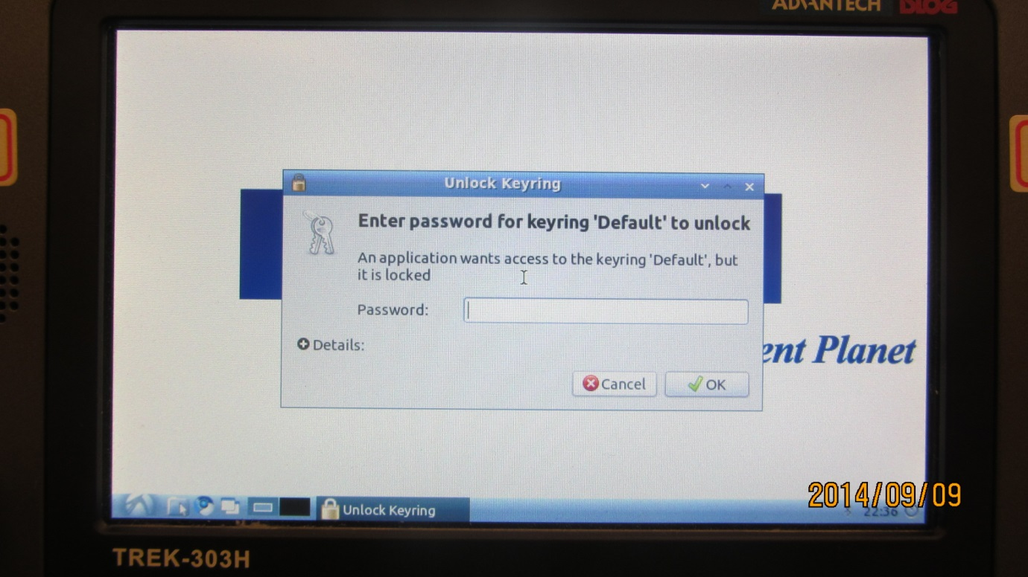

- Right click the internet (wireless or wired) icon.
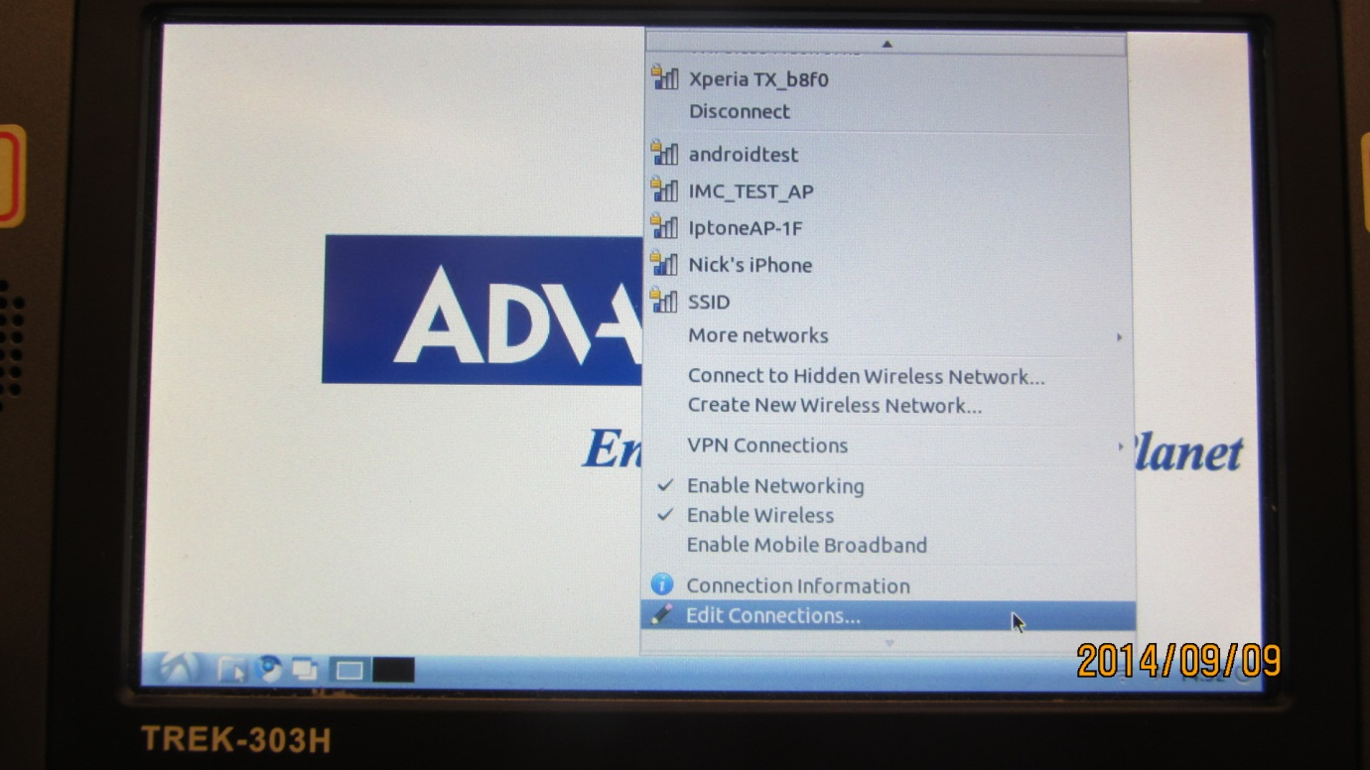

- Select the type of connection (wired or wireless) and Edit.
if wireless, select the name of your network. if wired, select eth0.
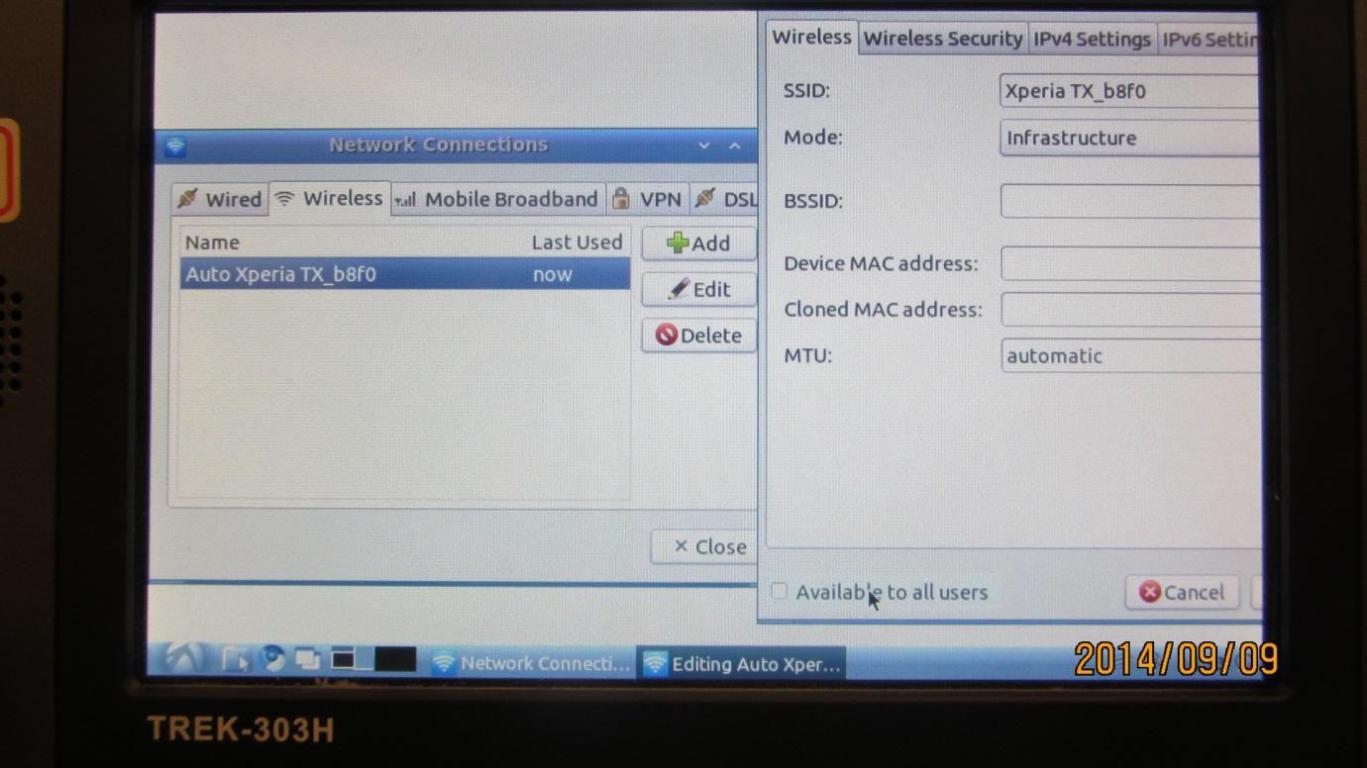

- Select "available to all users" box at the bottom of the box and click "save"
