PWS-870 Barcode Reader Function Settings
Data Create | 2014/10/24 | Release Note | □ Internal ■ External
Category | FAQ | Product Group | SAG
Function | Barcode reader | Related OS | WE8S
Related Product | PWS-870
[Abstract]
Go through some simple steps to troubleshoot the barcode reader non-working issue.

[Solution]
Double-click the icon in the system tray to open the SmartWedgeLite window.
If the icon can’t be found in the system tray, press Windows Key + Q on your keyboard and type “SmartWedgeLite” to find out and execute it.
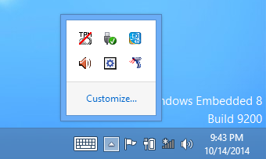
Select the existing device in the list. Click the “Remove COM port” button to remove it.
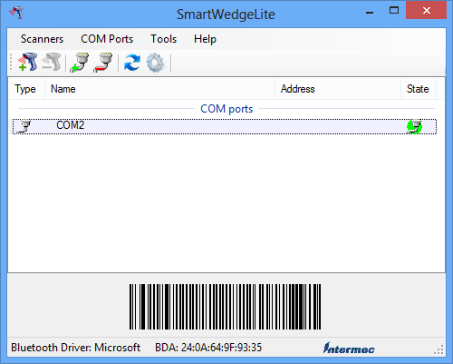
Click the “Add COM port” button to open the port adding window. Choose COM2 for Com name and 115200 for Baudrate.
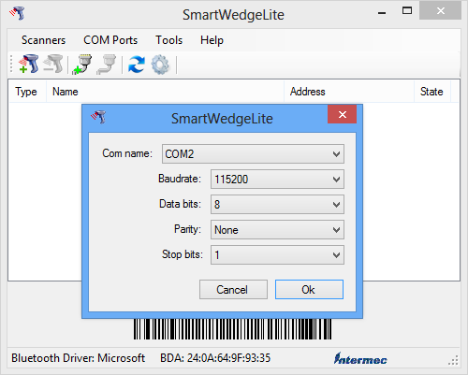
Double-click the “Advantech Control Center” shortcut on the Desktop. Go to the “Module” tab and click the “Hot Key Mode Setting” button.
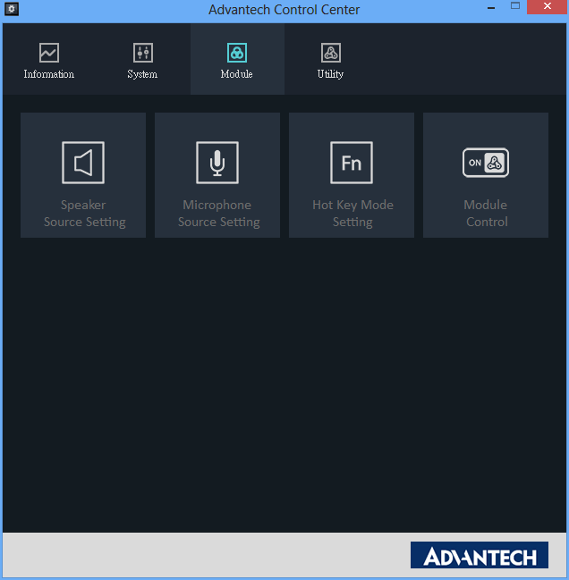

Choose the “Windows Key / Barcode” mode.
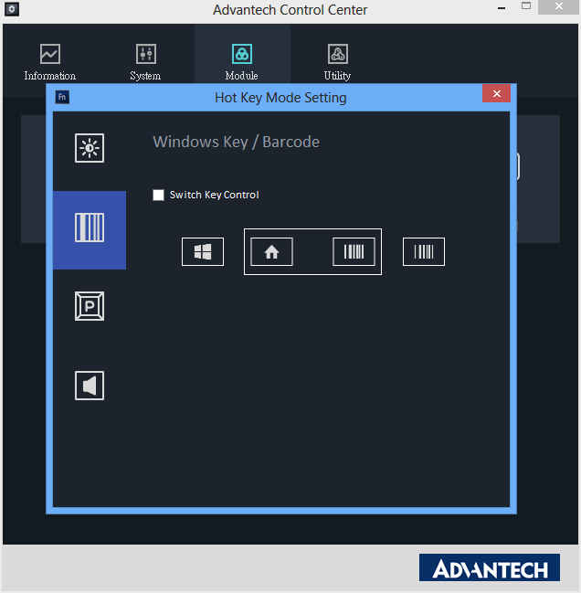
Open new a text document. Hold the PWS-870 carefully, press down the barcode button on the right of the panel, and use the barcode reader to scan a barcode. The content of the barcode will be displayed, which means the barcode reader functions well.
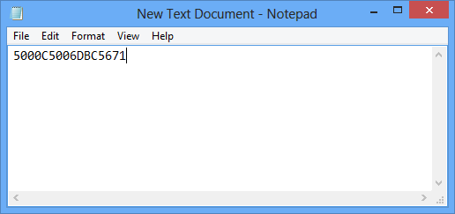
If there’s any decoding mistake with the displayed text, please redo this SOP from the first step again but set the Baudrate to 9600 this time.
9600

