Advantech AE Frequently Asked Questions
Data Create | 2014/10/16 | Release Note | □ Internal ■ External
Category | FAQ | Product Group | SAG
Function | Backlight off from Power management | Related OS | Win CE 5.0
Related Product | UBIQ-480 & UBIQ-480K

[Abstract]
Customer didn’t want to turn off display by power management. The display must always be turn on. How to disable the UBIQ-480’s backlight off?
[Solution]
- Please enter to control panel UI.
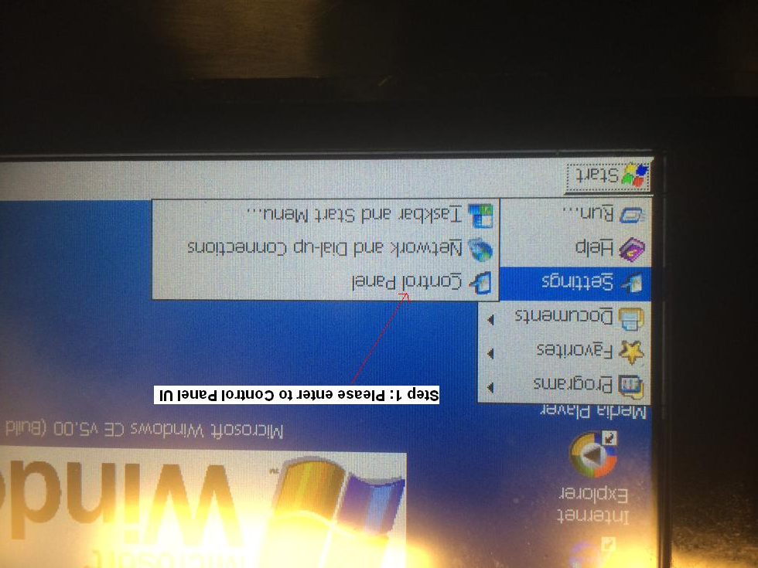
- Please enter Display UI and no click the backlight function.
