Advantech AE Technical Share Document
Date | 2021/10/15 | SR# | 1-3752738771
Category | ■FAQ □SOP | Related OS | N/A
Abstract | How to setup iRTU devices for resume broken transfer for cloud services?
Keyword | WISE-PaaS, Resuming Broken Transfer, WebAccess, Azure, private server
Related Product | ADAM-3600, ECU-1152, ECU-1251, ECU-1051

- Problem Description:

This document explains how to do 4 simple steps on EdgeLink for iRTU devices resume broken transfer for all kind of Cloud services. Such as SimpleMQTT, private server, WISE-PaaS, WebAccess, Azure, AWS,… etc.

- Answer:

For set up connection between iRTU and WISE-PaaS, please check:
FAQ: How to set up iRTU devices with WISE-PaaS
https://www.advantech.tw/support/details/faq?id=1-1KJ92NH
IAG_FAQ_ADAM-3600_How to set up EdgeLink devices with WISE-PaaS
https://www.advantech.tw/support/details/faq?id=1-1Q2A7SJ
How to set up ADAM-3600 or WebAccess MQTT connection with WebAccess Broker
https://www.advantech.tw/support/details/faq?id=1-1JJFS0P
How to set up ADAM-3600 to upload to Azure cloud
https://www.advantech.tw/support/details/faq?id=1-1IG5CKT
How to upload iRTU data to private server with SimpleMQTT
https://www.advantech.tw/support/details/faq?id=1-1MGCQMH

iRTU Devices TagLink Project Setup

- Set up TagLink project for iRTU devices. In this document, the demonstration is using “SYS_CURRENT_TIME” as the uploading tag.
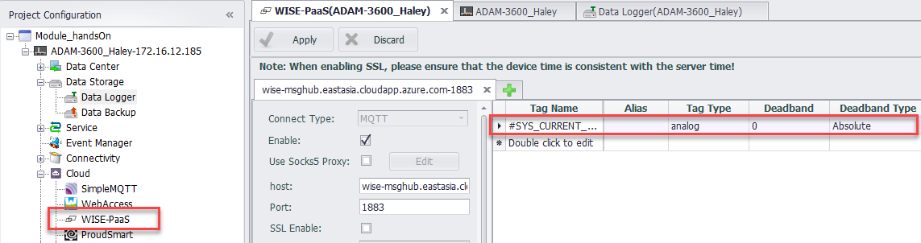

- Enable the “data logger” function with “SYS_CURRENT_TIME” tag.
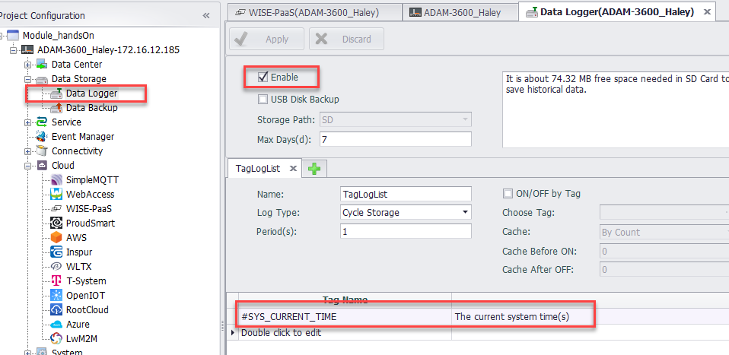

- Make sure SD card is using FAT32 format.
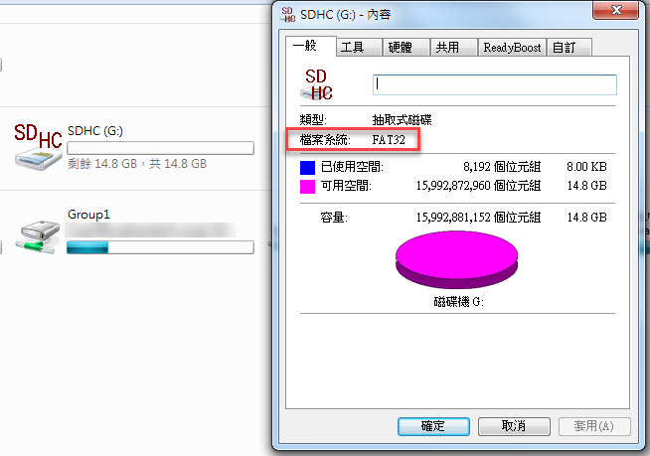

- Make sure the switch on the SD card is located at unlock.
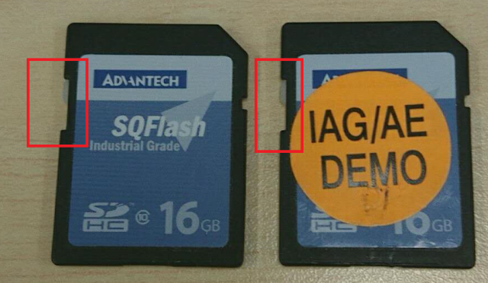

- Make sure the “enable data resume” is enabled.
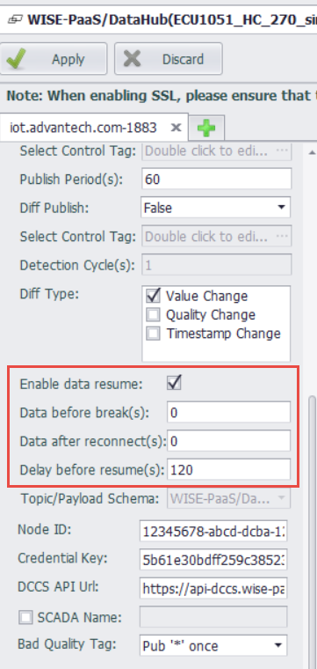
- Check the system time is adjusted. Most of CLOUD platform reject the connection if the system time is great different than the CLOUD platform system time.
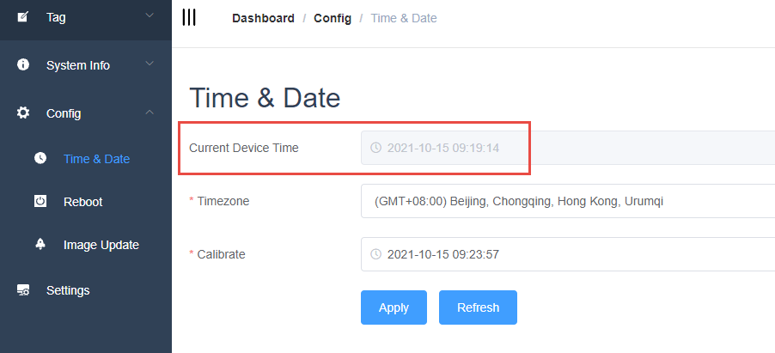
Troubleshooting tools
User can use one of the following #1 and #2 methods to do the troubleshooting or demonstration.
In this document, WISE-PaaS dashboard is used for the result demonstration.

- Create a dashboard on WISE-PaaS, to check if the data is received from iRTU.
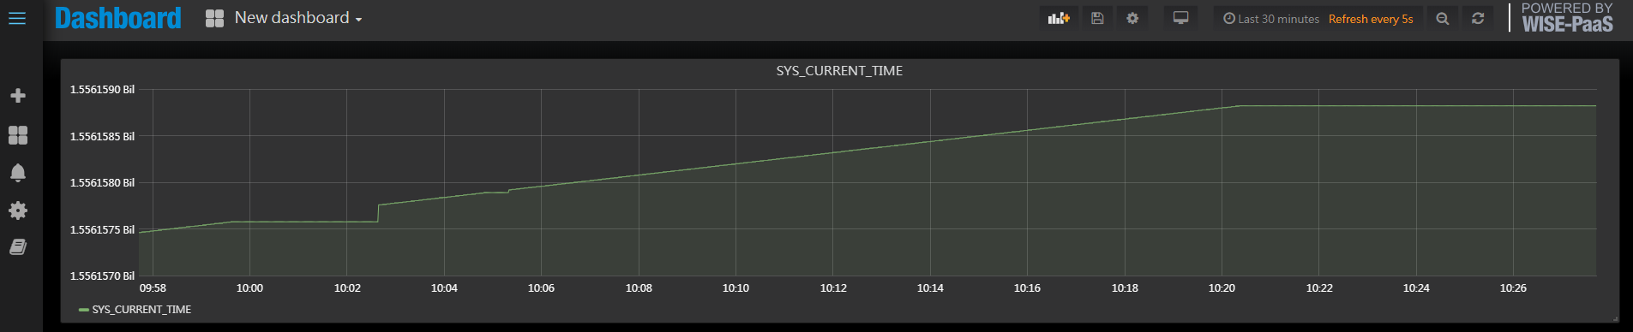
(During Internet broken testing)

- Create a 3rd party subscriber to subscribe data from WISE-PaaS MQTT broker.
In this demonstration, I use both WISE-PaaS and Paho.

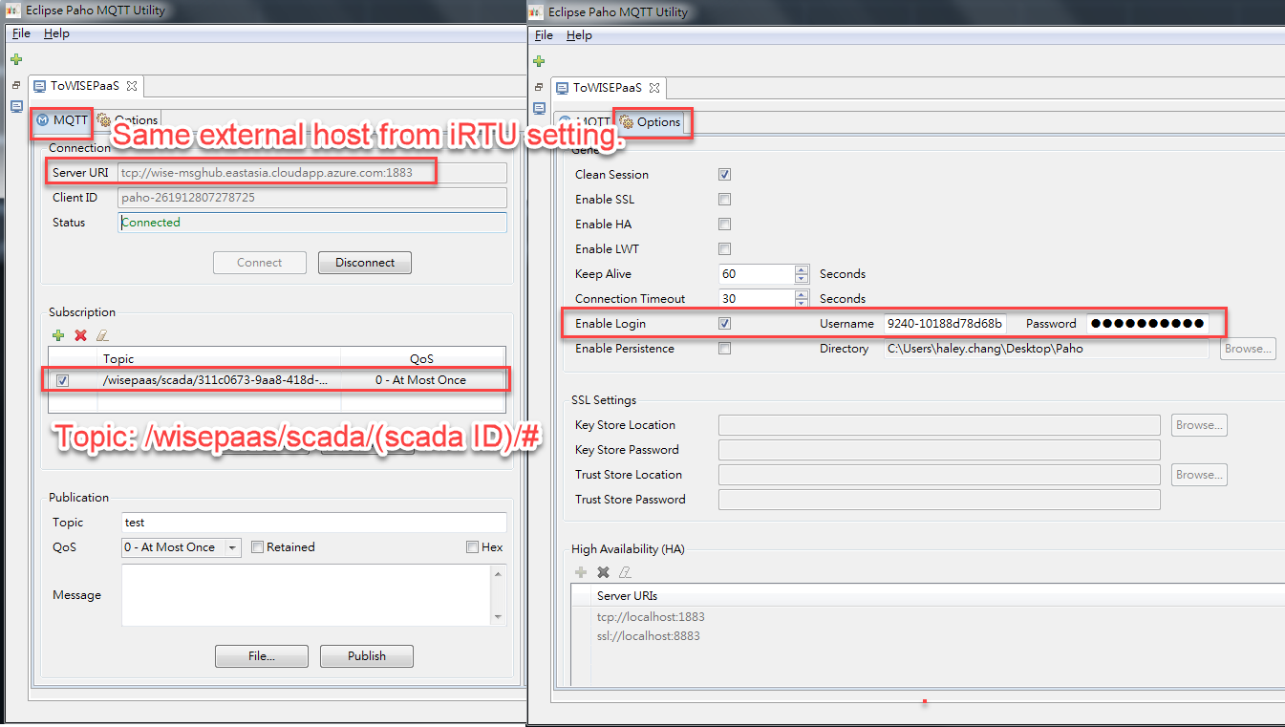
(Paho setting)
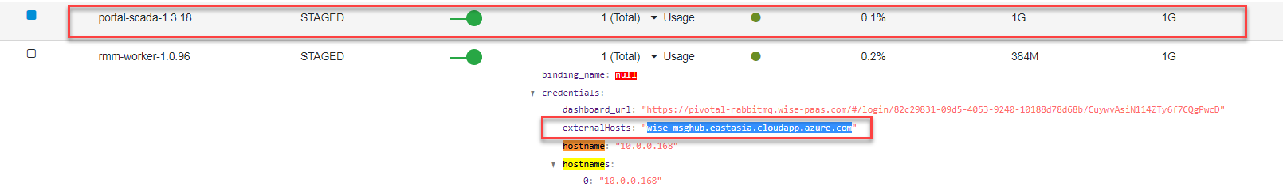
(External hosts)
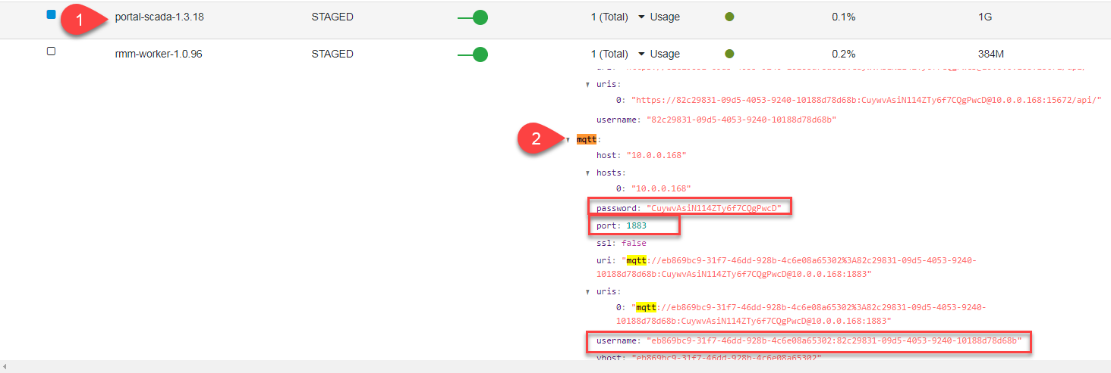
(Account and password of WISE-PaaS portal SCADA)

Results
- WISE-PaaS receives data from ADAM-3600 every 5 seconds.
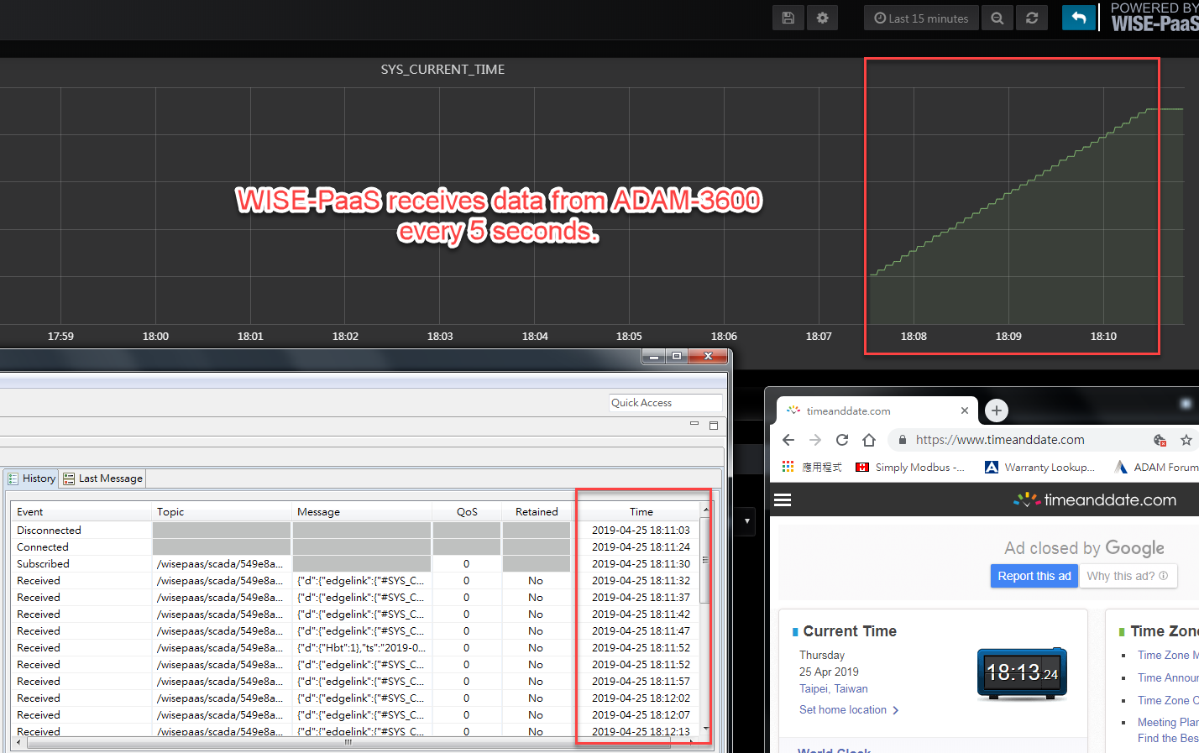

- Cannot receive data from ADAM-3600 after cut the Ethernet cable.
Timing: 18:14 ~
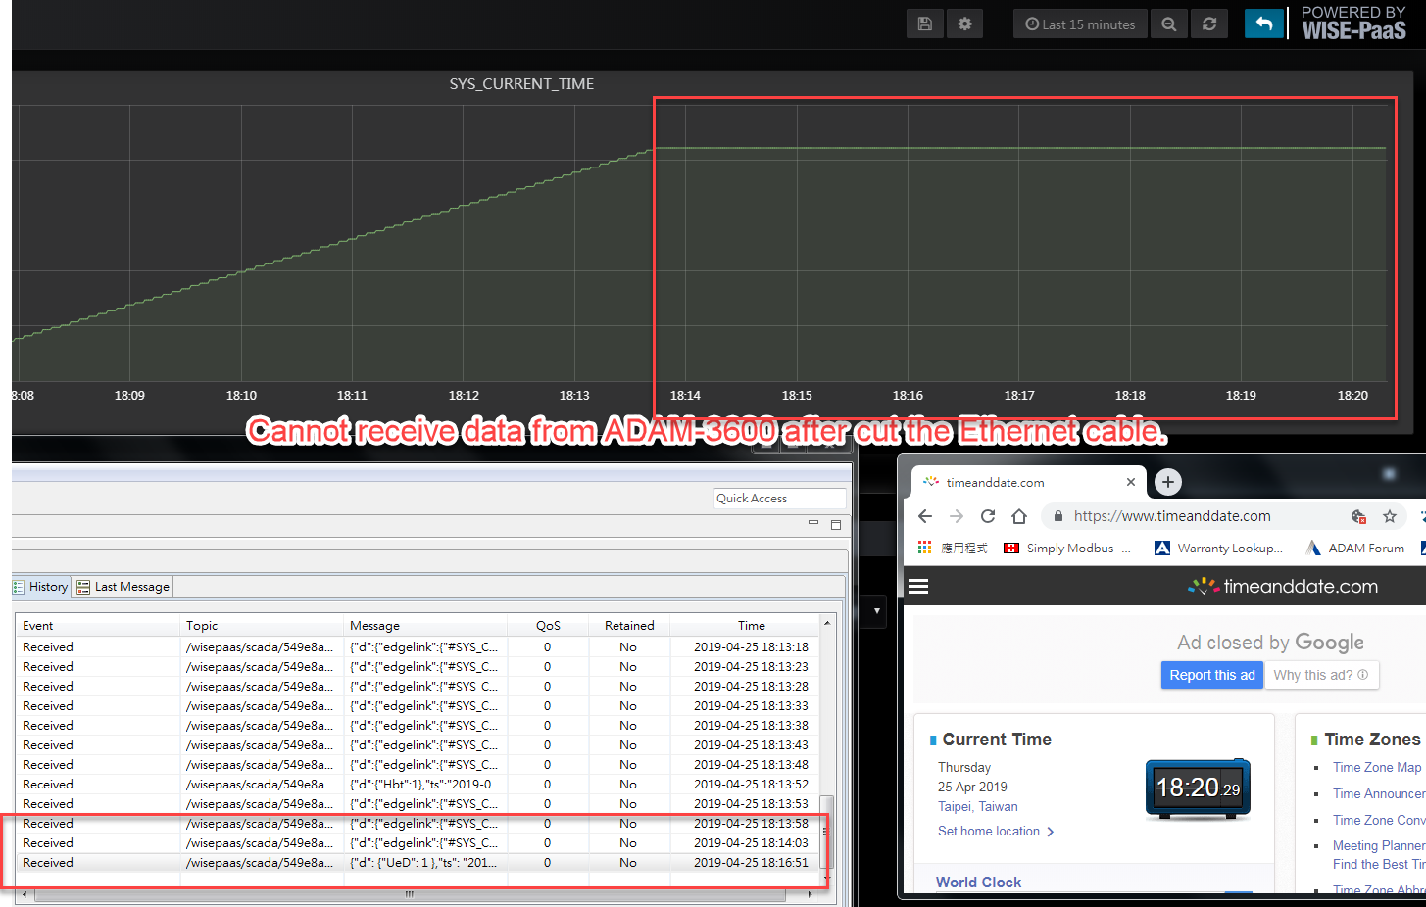
- The results of resume broken data after reconnect the Ethernet cable at 18:23
Timing: 18:14 ~ 18:24
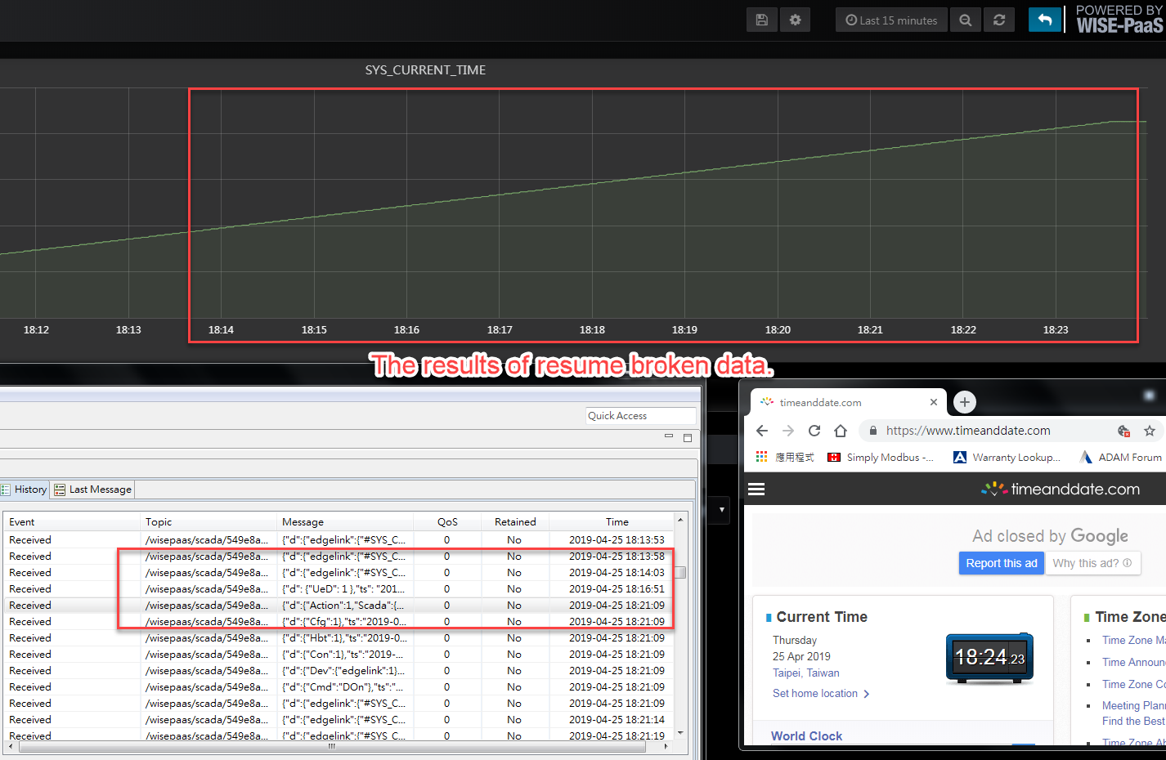
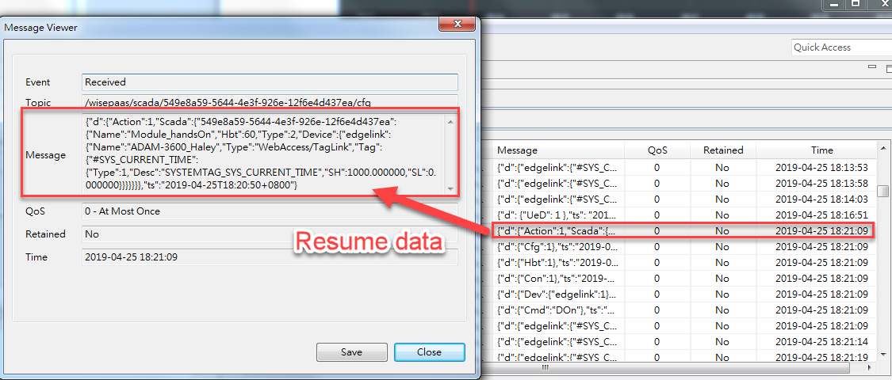
(Detail of the resume messages.)

